Homework 2： Order application

For this case study, you’ll create an application that allows the user to place an order at a fictitious coffee shop named Tuxedo Cat Coffee. Prerequisites: Chapters 1 to 8.

## User interface

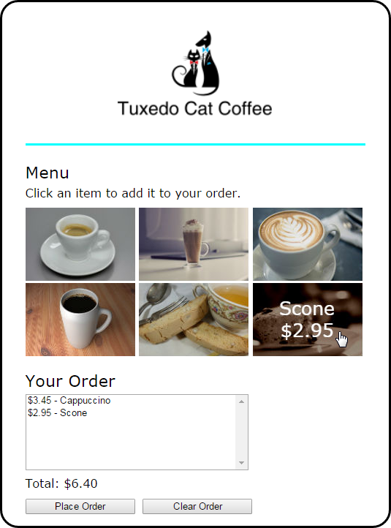

## Specifications

* When the user hovers the mouse over one of the images in the menu, another image should be displayed with the description and price of the item. The id attribute of each image identifies the image to be displayed when it’s rolled over.
* The rollover images should be preloaded.
* When the user clicks on an image, the order list and order total should be updated and displayed.
* If the user clicks the Place Order button, the checkout.html page should be displayed.
* If the user clicks the Clear Order button, all of the items should be removed from the order list and the total should be cleared.